Data Gathering – Business Needs
The main need is to integrate SNHU Clothing’s database with the new database XYZ Company. The SNHU Clothing and XYZ Company’s databases are in Microsoft Access. Data will need to go through ETL (extract, transform, load) for data to be integrated into a new database solution (SageIT, n.d.). Challenges include making sure the data is accurate and complete with consistent data fields so that the mapping of fields from XYZ Company’s database to that of SNHU Clothing only need be done once (Anwar, 2024). Cleaning the data is imperative before merging the databases. The goal is to migrate the Access databases to a more robust DBMS that will provide speed, reliability, and security while also being scalable.
Another need is actionable insights on customer behavior in the merged database to drive business decisions and targeted marketing. The goal is to enable the company to evaluate customer loyalty and discover opportunities to promote products based on customer behavior, preferences, and trends (Laudon & Laudon, 2022). The challenges stem from the merging of the databases. That will need to be completed before useful analytics can be generated.
Both the customer data and sales data are stored in the client systems and data integration is needed to bring them together. I chose this data because it will meet the needs for merging the database, accessing analytics, and gaining actionable insights. More work would need to be invested in creating analytic reports and dashboards with Power BI.
Customer data types include customer id, names, contact information including email addresses are typical for merging databases (Murthy, 2003). A primary key as a unique identifier is crucial to ensure there are no duplicate records. This will ensure a seamless transition by maintaining accurate and comprehensive customer profiles. I chose this because the customer and sales systems are the most important for driving sales and targeting customers with marketing campaigns.
Sales data types such as order number, customer id, product ID, product name, quantity, and unit price are imperative to gaining customer insights (Murthy, 2003). This data helps identify what products or types of products the customer has purchased and the average order total as well as how often they make a purchase. With this information, the company can run targeted marketing campaigns, promotions to current and new customers, and evaluate its effectiveness through analytic reports and dashboards.
Without both the customer and sales systems, insights would not be possible. There is little that a customer system alone can tell you, just contact information which would only be good for a mailing list but that does not integrate enough information to generate useful analytics.
Data Gathering – Current Systems
SNHU Clothing and XYZ Company currently use Microsoft Access to store sales, products, suppliers, customers, and vendors data. The challenge is in data mapping because the fields in each database are disparate, which would not allow for an easy merge of the two. Another challenge is scalability to accommodate their rapid growth and Microsoft Access is not scalable (Microsoft, n.d.).
Data Gathering – Accessed
To find the information that is currently available, I would speak with Mark Manager in IT. He could tell me what information there is and where it resides from a technical perspective. Additional steps would be to speak with the other managers to find out how useful they find the current system and what they would like to see in a new system, what would make their job easier. I would also review the schema of the database to know what data I’m working with. I would ask for an entity relationship diagrams (ERD) if available to see the relationships between the data in each database.
Data is currently stored on a desktop computer. This is very inefficient and unsecure and even more so as the company grows. The desktop version only allows for 2 GB of storage and the storage needed can increase dramatically. For instance, possibly SNHU Clothing decides to purchase more customer databases and inventory from other retailers. The data begins to grow exponentially, and Access cannot manage this with speed, reliability, and efficiency. Additionally, with the system existing on a desktop computer, data security is also insufficient and simply not an ideal configuration.
There are services and APIs to collect and analyze data. Amazon Redshift is one system that can do this, and it is available through AWS. It is a serverless option for accessing and analyzing your data without all of the configurations of a data warehouse and it is automatically scaled (Amazon, n.d.). Another tool is a Google Analytics API which integrates with the database to collect and report on the information. You can also use a tool such as Power BI to work with analytic visualizations and draw insights from the data. It can also create dashboards and reports that answer questions in real-time (Hashemi-Pour, 2024).
According to Cybers Crime Magazine, 60% of small businesses go out of business within 6 months of a data breach or attack (von Ogden, 2019). Around the end of 2022, data breaches rose by 70% globally. Breaches can expose personally identifiable information, proprietary and confidential information, and allows hackers to access and steal information (Metomic, 2024). This results in losing customer loyalty and trust, degraded reputation, violating regulations like the General Data Protection Regulation (GDPR). Ways to mitigate this are encryption, security audits, using multifactor authentication for remote access, using appropriate access controls for users, and keeping security tools up to date (Fortinet, n.d.).
Business Needs – Questions
- How many total customers have been acquired from XYZ Company’s database?
- Do we have data on customer loyalty and/or engagement?
- What is the sales volume by store in each system?
- How many customers from both systems live within 25 miles of a store?
- Are there other areas where at least 25,000 customers are located?
  - We want to see what areas potential new store locations would be.
- How many employees should we have per store based on sales?
- This will become critical as we expand our physical footprint with more stores up and down the East Coast.
Business Needs: Link
The client systems are related through Microsoft Access but the field names do not match up so we will need to manually match the fields and then determine how many records we are working with prior to merging the two databases. If the records do not exceed 1,048,576 records, we can use Excel to clean the data in each database prior to the merge (Microsoft, n.d.). We must ensure that all records are unique so no two customers can have the same customer number before the databases are merged.
We will merge the databases based on the matched fields. We will need to make sure we are collecting the same information in the new database as we do from the current databases going forward (See Appendix A). This is the time to add new fields to start collecting additional data, if desired. We will need to do this if there are fields from XYZ Company’s database that you would like to include in the new database.
For a period after implementing the new system, we can continue to use the current system, with the separate databases, for reference only and all new data should be entered in the new system. If users find there is data missing or duplicated, we will use the new IT ticket system to address these. We will put controls in place that do not allow new records to be added or edited in the current or newly purchased databases. Once we merge the databases, we will be able to run combined reports and see an overall picture of the data and run ad hoc reports.
Our goal is a new system that is scalable and will accommodate the growth of the company across all divisions and offer detailed analytics to draw insights on customers, sales, inventory, suppliers, products, and shipping. This will include a Customer Relationship Management (CRM) system, either as an all-in-one system or ala carte systems, which are connected so all information can be viewed through an analytics tool, Power BI, for analysis. If we go with separate applications for different divisions, we will have systems for Sales and Marketing, Manufacturing and Product Design, Warehouse, and IT as well as an in-store POS system, all as separate systems.
Additionally, the plan is to store the database on a cloud server which means we do not have to buy or set up and maintain servers and we can connect all locations to the same system for a monthly fee. You pay for the storage you need as you need it so there is a cost-saving benefit to this (AWS, n.d.). With cloud storage, we get the added benefit of heightened security of your data as well as scalability.
If we go with Microsoft Azure SQL Server, the process of migration is much simpler than to other products. Microsoft Access is also a Microsoft product that eases the level of complexity in connecting some of the other Microsoft systems like Power BI.
We will assign access permissions based on the department’s need-to-know basis. Not everyone will have access to all the information in the company. We can control who sees what.
Business Needs: Gaps
I will create an Entity Relationship Diagram (ERD) for the current database, if not already available, so we can review the type of information we have been collecting and what XYZ Company was collecting in their database. Then I will create another diagram for the new database where we can brainstorm other fields we may want to add. (See Sample in Appendix A).
Additionally, a unique number is needed for each record of information, for instance, a customer number and product number. This means that we need to take additional steps if XYZ Company’s database has some of the same customer numbers and product numbers as our current database. By addressing this, it ensures we have clean data that is not duplicated in the new database. Considering we are merging two disparate databases, a strategy to address this is threefold.
First, we match up the fields manually from XYZ Company’s database to SNHU Clothing’s database. Second, when cleaning the data, we can append a number to the beginning or end of customer numbers, product numbers, and supplier numbers for those imported from the other retailer’s database. For instance, we can append customer numbers with another column called subkey with 001 for SNHU Clothing and 002 for XYZ Company’s identifier numbers. Our primary identifier would be a composite of the regular customer number plus the subkey. Duplicate primary keys are not allowed so if we add the subkey, the combination of the two is called a composite key (Winsberg, 2022).
In having duplicate customer ids, the additional column will make it unique when you combine the two. This will serve as the system’s unique identifier. It will also make it easier to distinguish SNHU Clothing’s customers from the new customers imported from XYZ Company. We will do this for the sales and marketing system with customer numbers and order numbers, for manufacturing and product design system with product numbers, for IT system with ticket numbers, and Warehouse system with purchase order numbers.
Third, we merge the two databases so we end up with one database that combines the information so you will not need to work in two systems after the merge, implementation, and testing are complete.
Integrating Business Reports: Reports
How many total customers have been acquired from XYZ Company’s Microsoft Access system?
We can run a query from the database that shows the total number of customers based on the composite key (a primary keys and subkey, when combined is unique) where we filter for those with the subkey identifying XYZ Company’s customers.
Do we have data on customer loyalty and/or engagement?
We can find out this information by reviewing the data fields XYZ Company was collecting in their database. We can cross-reference this with the sales data as well so long as a customer number is included with each sales order.
What is the sales volume by store and for e-commerce in each Microsoft Access system?
We can run queries for sales information grouped by store and customer location to show the distribution of sales channels and regions. Although there is currently only one store, this provides scalability as the company grows and data increases which can happen quickly.
How many customers from both systems live within 25 miles of a store?
We can run queries by city and state to show where all the customers reside and incorporate geographic data to total the number of customers in each area that is within 25 miles of any SNHU Clothing store. Depending on whether we are buying stores in addition to the database, we can do the same thing and add new stores when we merge the databases as long as we have the store information.
Are there other areas where at least 25,000 customers are located? We want to see what areas potential new store locations would be.
We can run queries to pull the number of customers by utilizing the filter to exclude customers that are already within 25 miles of a store. This will require a geographical database by zip code to identify the exact locations of customers for reporting purposes.
How many employees should we have per store based on sales?
We need to know the total sales per store and do a cost analysis to figure out the ideal ratio of customers to salespeople. For instance, we might find we maximize ROI with 1 salesperson for every $5000 in daily sales. If we run a sales report on the merged database showing each store and their respective total daily sales average over 12 months and then divide it by $5000, that gives the ideal number of employees per store.
Integrating Business Reports: Report Linking Data
The information needed from Sales and Marketing, Manufacturing and Product Design, and Warehouse are structured interviews with the same questions because they are open-ended and focused on finding out the underlying issues of what problems they face in the current system and what would help make that process easier. The questions for the CEO are different because they would want to see higher-level reporting not applicable to middle management. The interviews with IT would be much different because the discussions could be more technical. Following are the departments and questions to be asked.
CEO
Type of info needed for reports
  - What type of information do you need to see and how often? This will enable us to make sure the system provides what you need in the format you need it.
  - How do you use the information? This will help us understand your processes and decision-making methods.
  - Will you be running ad hoc reports or standardized reports? This will allow us to create automatic reports or provide tools to manipulate the data and pull the information you need.
  - Who should have access to information and which information should each department and individual have access to? This will give us the information needed to set up access permissions to data so that employees only have access to what they need to do their jobs.
  - What is your budget for the project?
IT Manager
Type of info needed for reports
  - Do you have a database dictionary for either or both databases? (Laudon & Laudon, 2021). This will help us to design the new system where the data from the two databases will be merged and include all fields for data that will be collected going forward.
  - How are permissions currently set? This will allow us to understand the hierarchy of information access and be a starting place for a conversation with David Officer to determine if the accesses should stay the same or be revised.
  - How many records are in each database? This will determine if Excel can be used to clean data or if it is too large and we must use a more advanced technical tool to query the data.
Sales Manager
Type of info needed for reports
- What is the most important information to you? What do you use the data for? This will help us
- How do you currently access that information? How often?
- What do you wish the system could do to make your job easier?
Warehouse Manager
Type of info needed for reports
- What is the most important information to you?
- How do you currently access that information? How often?
- What do you wish the system could do to make your job easier?
Manufacturing and Product Design Manager
Type of info needed for reports
- What is the most important information to you?
- How do you currently access that information? How often?
- What do you wish the system could do to make your job easier?
Integrating Business Reports: How and Who
For most of the departments, I would need to ask similar or the same questions to learn their process, what they like about the system, what are the challenges or bottlenecks, and what would make their job easier. I also need to know who my primary contact should be throughout this project.
I would set up a meeting with the CEO and IT manager to get a list of needs and wants as well as current limitations in business processes, systems, and budget. Additionally, I need to know who should have access to what information within the company on the new system. Will the new system modify your business processes, or do you want to have the system customized to your current business processes? What different systems are currently being used throughout the company and by who?
I would also meet with the sales manager for an overview of what they do and what information they need to make decisions and monitor the sales department. I need to understand their process and how they use the current system.
I would set up a meeting with the warehouse manager in person at their physical location to see how their process works and to walk me through how they currently use the system, what are the challenges, and what do they like and do not like.
I would meet the manufacturing and product design manager in person at their physical location to see how their process works and to walk me through how they currently use the system, what are the challenges, and what do they like and do not like.
Additionally, I would like to get input from end users about how they use the system from a different perspective in lieu of the managers alone. If we get input from every level, it is more likely that employees will feel invested and, in turn, increase acceptance overall (Laudon & Laudon, 2021). We can use employee surveys or one associate from each division whose primary job is working in the applicable system or systems to participate in the data gathering process and testing.
All this information will help me to design a system that meets the unique needs of each department and gives me an understanding of how each of their processes works in more detail versus the overview provided in the business processes diagram alone. There may also be opportunities to improve business processes to work with the system and increase efficiency instead of customizing the system to match current business processes (Laudon & Laudon, 2021).
Integrating Business Reports: Reporting Tools
Although Tableau is the top-rated reporting tools based on industry feedback and user reviews, Power BI is a Microsoft tool, has similar features, and can be easily integrated into Microsoft systems. Power BI can be used to create reports which are static and dashboards that are interactive. Reports can be created from any data source in the system and it is simple with the drag and drop features. We can pull in sales data to model reports that show volume and dollar values. Another great feature is being able to easily share the data with others. You may find a dashboard extremely useful if you pull a lot of ad hoc reports. Alternatively, you may need a Power BI expert to create the dashboards but then anyone with access can view the data and manipulate it to their preferences of what they want to see. It is quite intuitive and you will likely find the interface very familiar to other Microsoft products.

Appendix A – Entity Relationship Diagram for new system
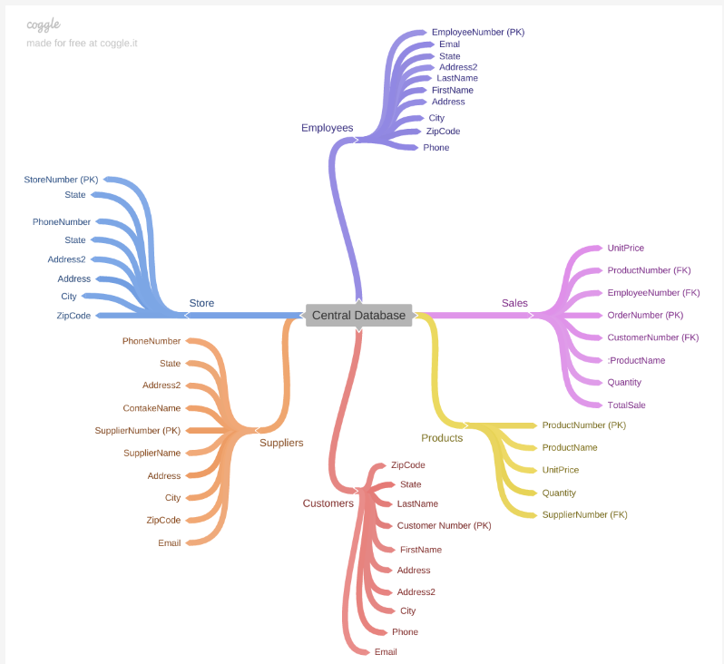

Appendix B - System configuration

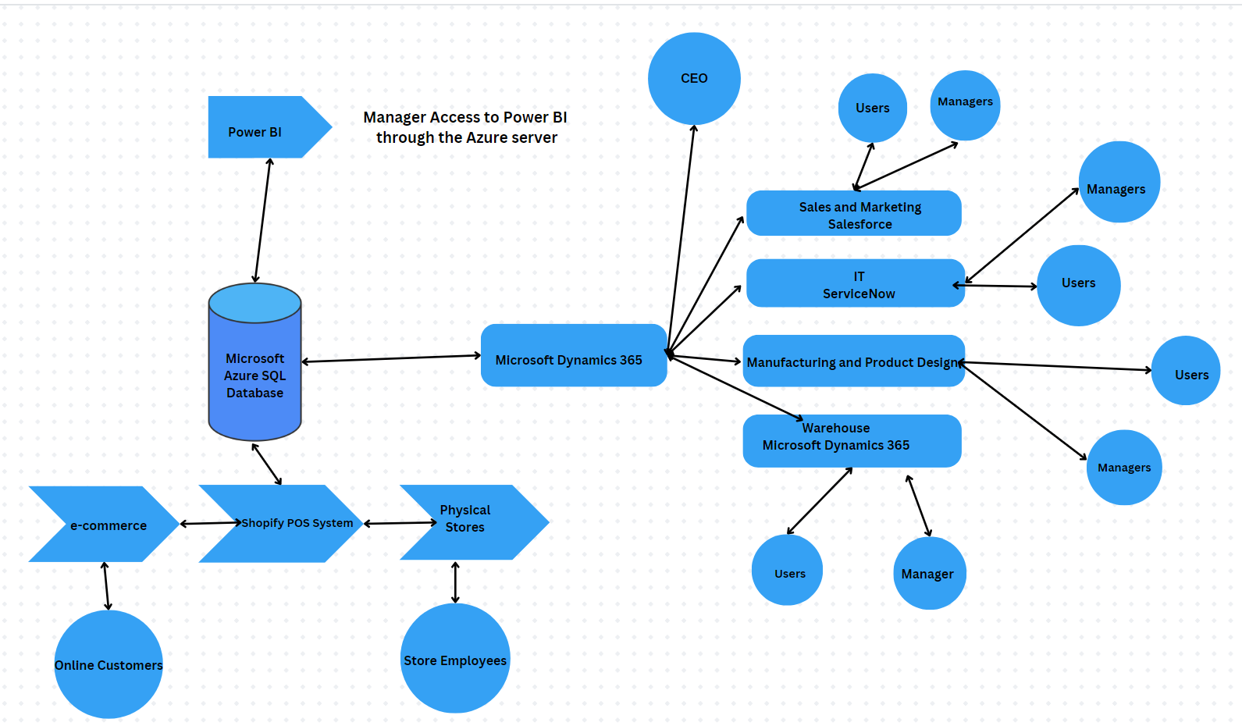

References
Amazon. (n.d.). What is Amazon Redshift?. https://docs.aws.amazon.com/redshift/latest/
mgmt/welcome.html
Anwar, M. (2024, March 20). Data merging essentials: Process, benefits and use-cases. Astera
blog. https://www.astera.com/type/blog/data-
merging/#:~:text=Clean%20and%20transform%20data%3A%20It,structure%20and%20the%20intended%20goals.
AWS. (n.d.). Cloud storage on AWS. https://aws.amazon.com/products/storage/
Coursera. (2024, May 14). 5 business intelligence tools you need to know.
https://www.coursera.org/articles/bi-tools
Hashemi-Pour, C., Scardina, J., & Horwitz, L. (March 2024). Microsoft Power BI.
TechTarget. https://www.techtarget.com/searchcontentmanagement/definition/Microsoft-
Power-BI#:~:text=Microsoft%20Power%20BI%20is%20used,BI%20users
%20within%20the%20organization
Kullman, R. (2017, January 17). Reap the benefits of SQL Server over Access. Migrate to .Net.
https://www.migrateto.net/migrate-access-to-sql-server/.
Migrate an Access database to SQL Server. (n.d.). Microsoft.
https://support.microsoft.com/en-
us/office/migrate-an-access-database-to-sql-server-7bac0438-498a-4f53-b17b-
cc22fc42c979
Laudon, K.C. & Laudon, J.P. (2021). Management information systems managing the digital
firm. Pearson.
Microsoft. (n.d.). Excel specifications and limits. https://support.microsoft.com/en-
us/office/excel-specifications-and-limits-1672b34d-7043-467e-8e27-
269d656771c3
Microsoft. (2024, May 2). Vendor collaboration with external vendors.
https://learn.microsoft.com/en-us/dynamics365/supply-chain/procurement/vendor-
collaboration-work-external-vendors
Microsoft. (n.d.). Turn data into impact across departments. https://www.microsoft.com/en-
us/power-platform/products/power-bi/power-bi-and-dynamics
Microsoft. (2023, November 10). Power BI usage scenarios: Managed self-service BI.
https://learn.microsoft.com/en-us/power-bi/guidance/powerbi-implementation-
planning-usage-scenario-managed-self-service-bi
Murthy, U.S. (2003). Customer table. Science Direct.
https://www.sciencedirect.com/topics/computer-science/customer-
table#:~:text=Customer%20tables%20typically%20have%20a,used%20to%20store
%20customer%20complaints.
Salesforce. (n.d.). Microsoft Dynamics 365 sales connection.
https://help.salesforce.com/s/articleView?id=sf.sdp_connectors_msdynamics_settings.
htm&type=5
ServiceNow. (n.d.). IT operations management (ITOM).
https://www.servicenow.com/products/it-operations-management.html

Shopify. (n.d.). Get the point of sale to power your scale.
https://www.shopify.com/pos/large-retailer-
pos?utm_source=google&utm_medium=cpc&utm_campaign=RetailPOS_Brand_A
MER_US_Brand&utm_content=Retail_POS&_bt=690043554910&_bk=shopify%20re
tail%20pos&_bm=p&_bn=g&_bg=104134469641&gclsrc=aw.ds&gad_source=1&gcli
d=Cj0KCQjw-5y1BhC-ARIsAAM_oKmwgojonf3cexZYYlNG-1Bam-
BKK70M6RHtNkijyezX__OTzHgVkioaAugyEALw_wcB
Sunrise Technologies. (n.d.) Outdoor apparel leader gains scalability and visibility, cuts costs
with ERP solution.
https://pages.sunriseconsult.com/rs/sunrisetechnologies/images/Microsoft%20Dynami
cs%20AX%20Case%20Study-Patagonia.pdf
von Ogden, J. (2019, January 2). 60 Percent Of small companies close
within 6 months of being hacked. Cyber Crime Magazine. https:
//cybersecurity entures.com/60-percent-of-small-companies-close-
within-6-months-of-being- hacked/#:~:text=Beyond%20the%20financial%20consequences%20of,data%20
breach%20or%20cyber%20attack
What Are The Benefits of Keeping Customer Data Secure?. (2024, June 27). Metomic.
https://metomic.io/resource-centre/what-are-the-benefits-and-risks-of-keeping-
customer-data-secure#:~:text=Data%20breaches%20can%20expose%20
your,and%20impact%20your%20brand%20reputation
What Is A Data Breach?. (n.d.). Fortinet. Accessed 2024, July 18.
https://www.fortinet.com/resources/cyberglossary/data-breach
What is data integration? A comprehensive guide for beginners. (n.d.). SageIT.
https://sageitinc.com/reference-center/what-is-data-
integration#:~:text=Next%2C%20data%20pipelines%20serve%20as,to%20ensure%20
compatibility%20and%20coherence
Winsberg, P. (April 2022). Introduction to structured database environments. zyBooks.
https://learn.zybooks.com/zybook/DAD-220-13205.202451-1/chapter/1/section/1

