Here, I joined all of the tables so that I could pull the state from the Collaborator table then count the number of returns from the RMA table. I used the Orders table in order to tie the two together since State is only in the Orders and Collaborators tables but I needed to incorporate the returns from RMA table.

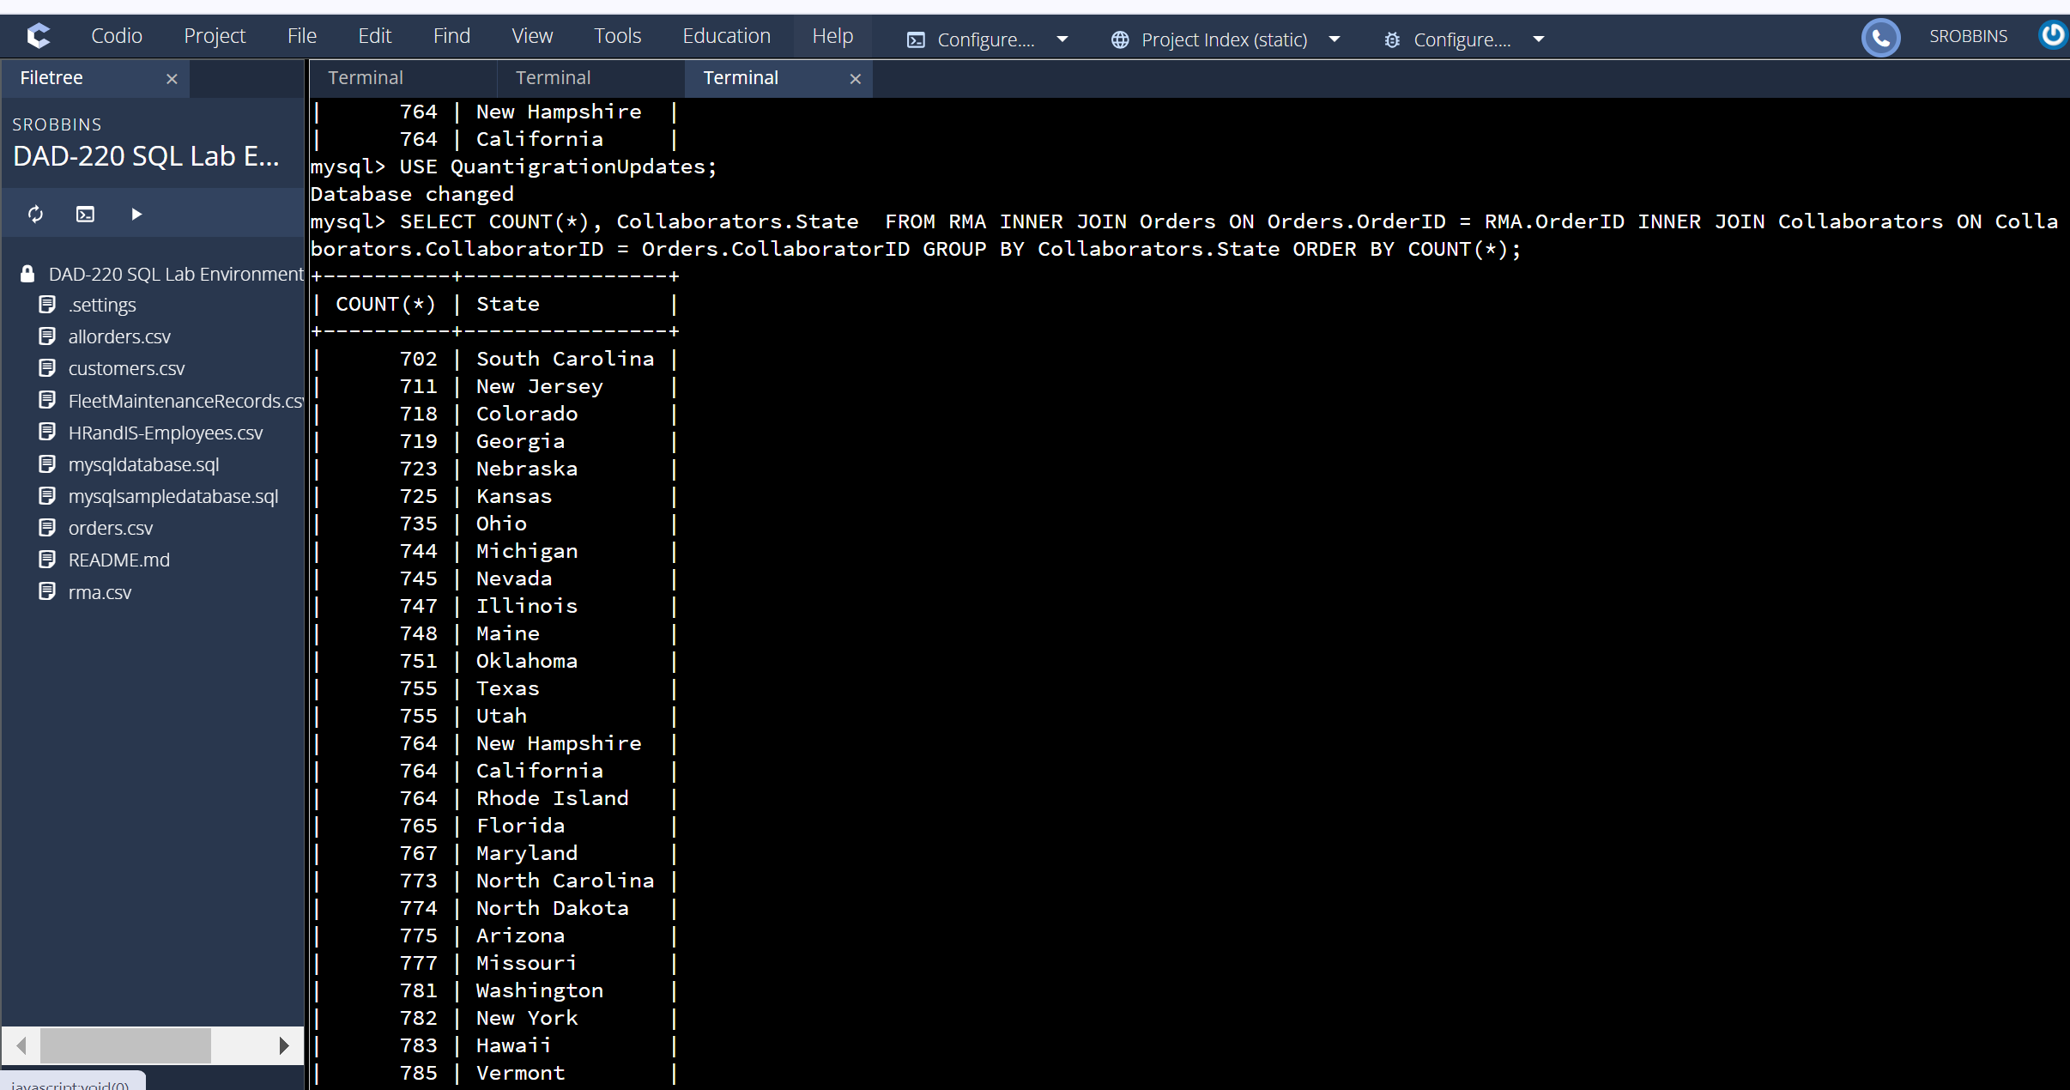
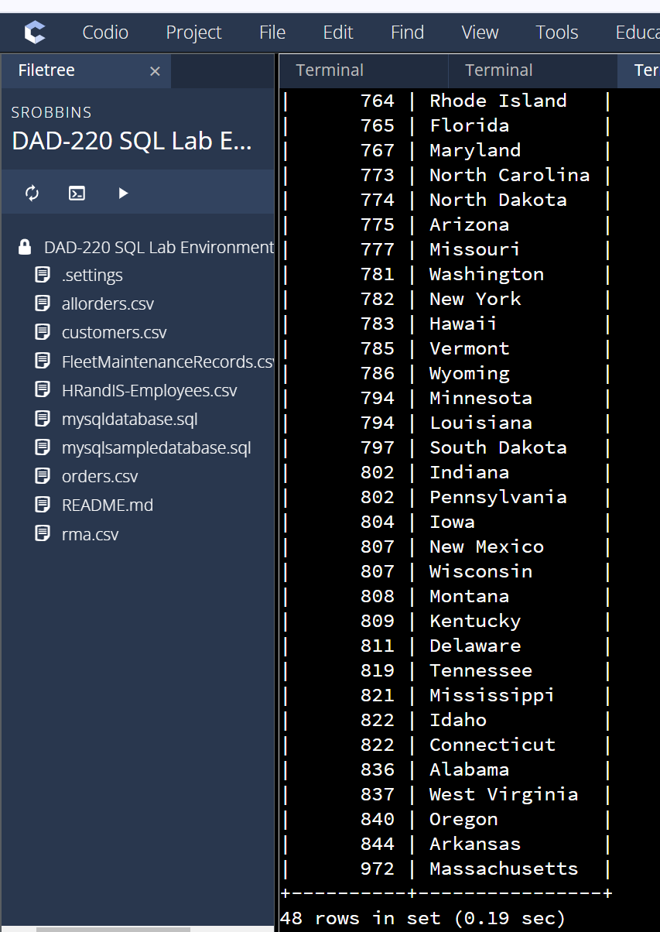

Here, I used a subquery to count the orders and joined it to RMA with an Inner join in order to compute returns divided by orders then grouped by the description which resulted in a list of products and the percentage of return next to it.
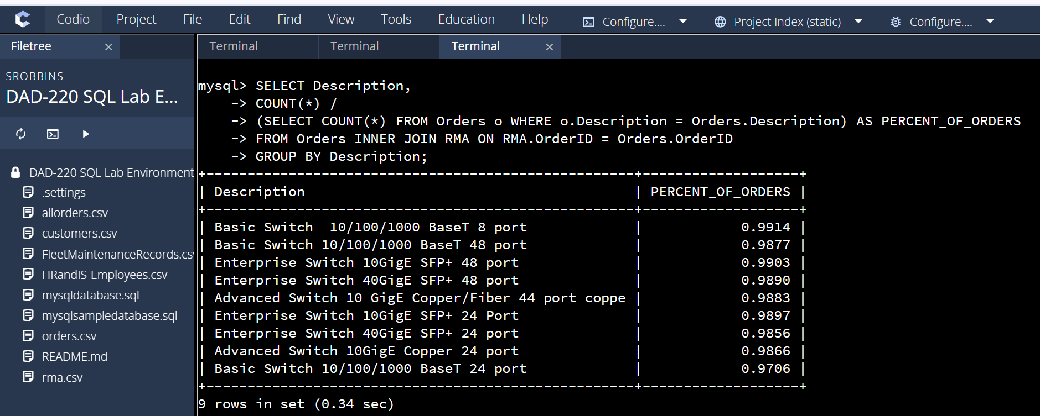

I wanted to see the comparison of orders to returns on each product to get an idea of the differences. This is how I discovered the total number of orders and total number of orders grouped by description. This was helpful in addition to the percentage of returns.

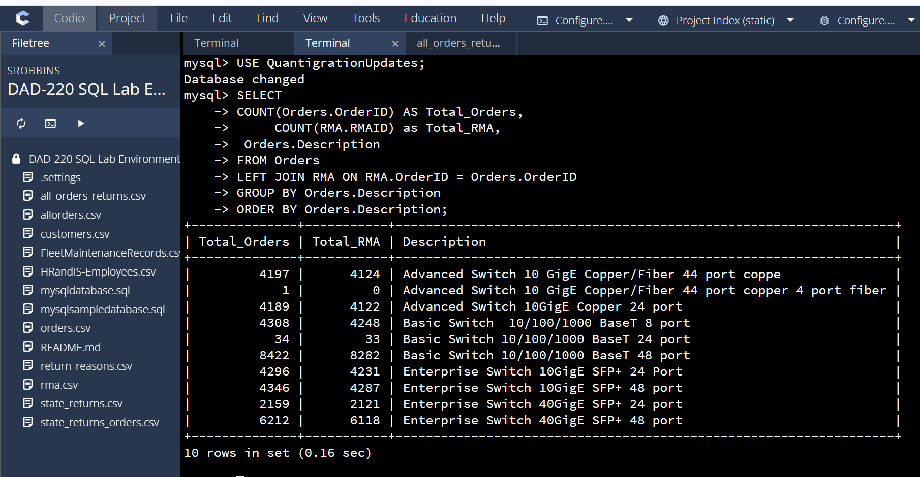

Here, I wanted to see why there were so many returns so I queried the DB to count all returns and group them by the reason for return then the product with a count for each. It was interesting to see how many were returned because the incorrect product was shipped. I thought this was a significant insight that the manager would want to see since they could address the high number of returns by coaching the shipping department to be more careful or institute quality checks to ensure accuracy.

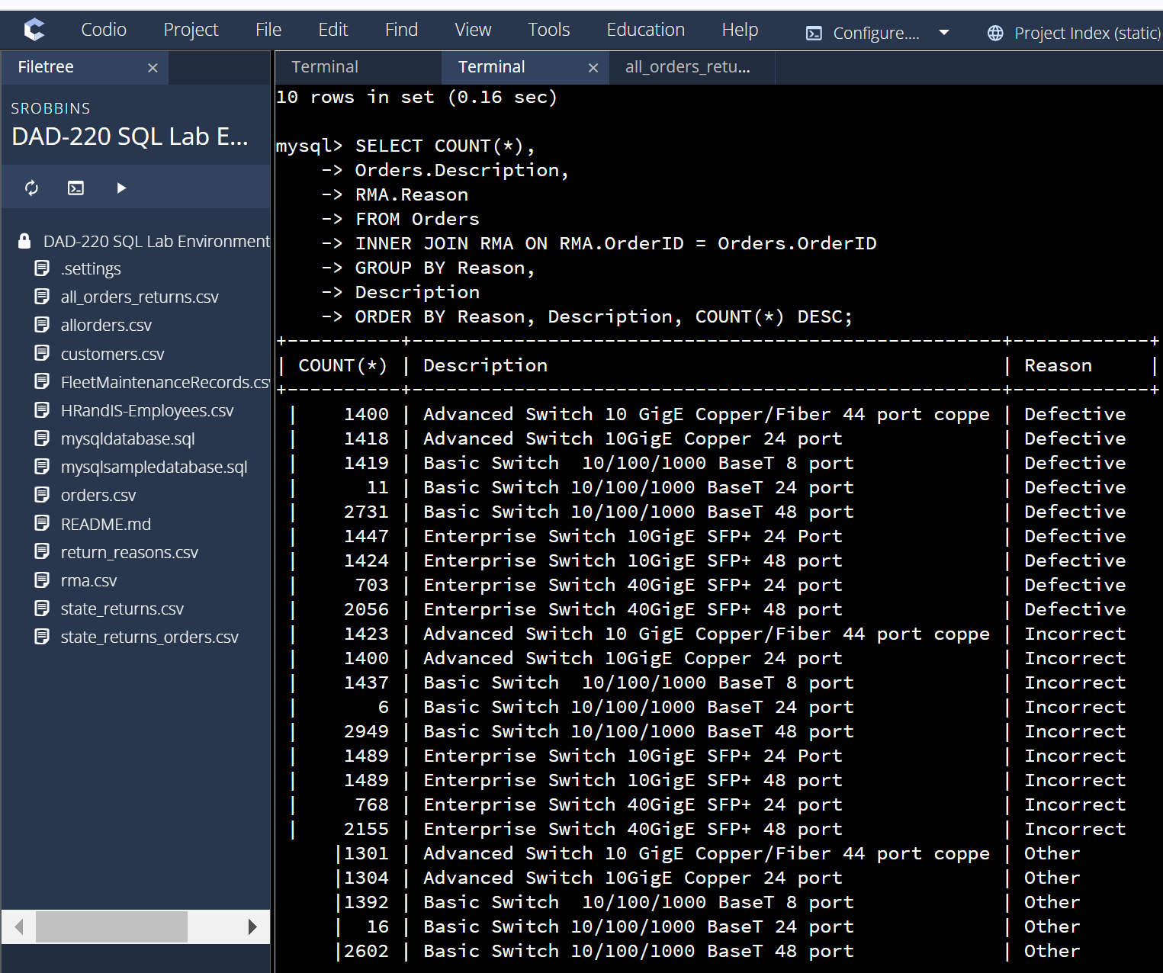

This report aims to provide you with the information you need on returns. There were insights I discovered that I think you will find interesting.

The top 10 states with the highest number of returns:

Clearly by far it is Massachusetts has the highest number of returns but this is also where the highest number of orders come from. We will explore that later.

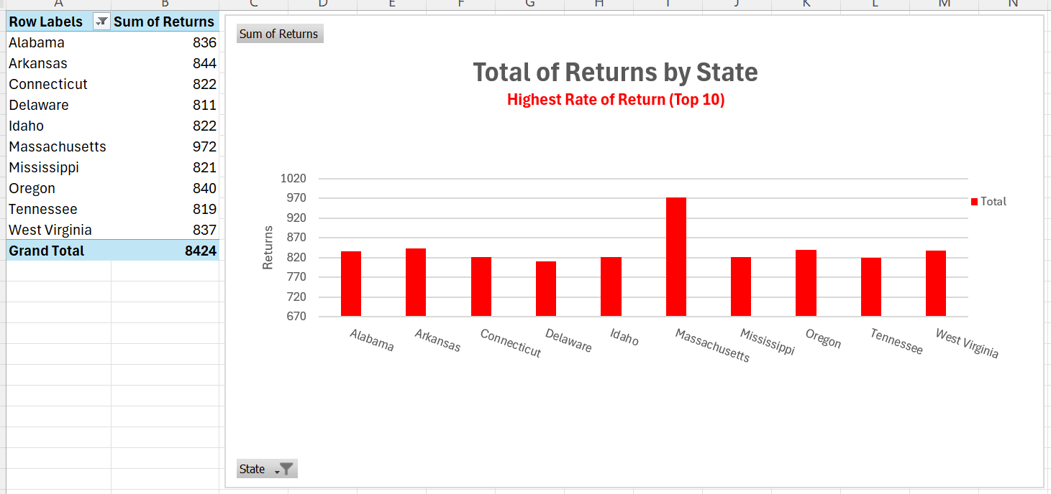

The top 10 states with the least number of returns:

South Carolina has the least number of returns but they are also not an area we traditionally see a lot of orders. We will explore this in the next section.

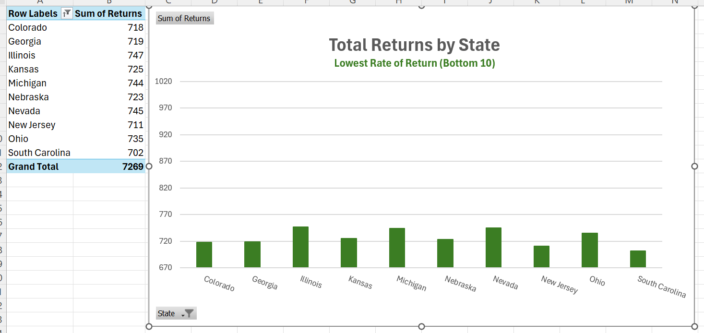

Now let's compare the percentage of orders to returns by state.

Top 10 states with the highest percentage of returns vs orders:

The highest percentage is Massachusetts.
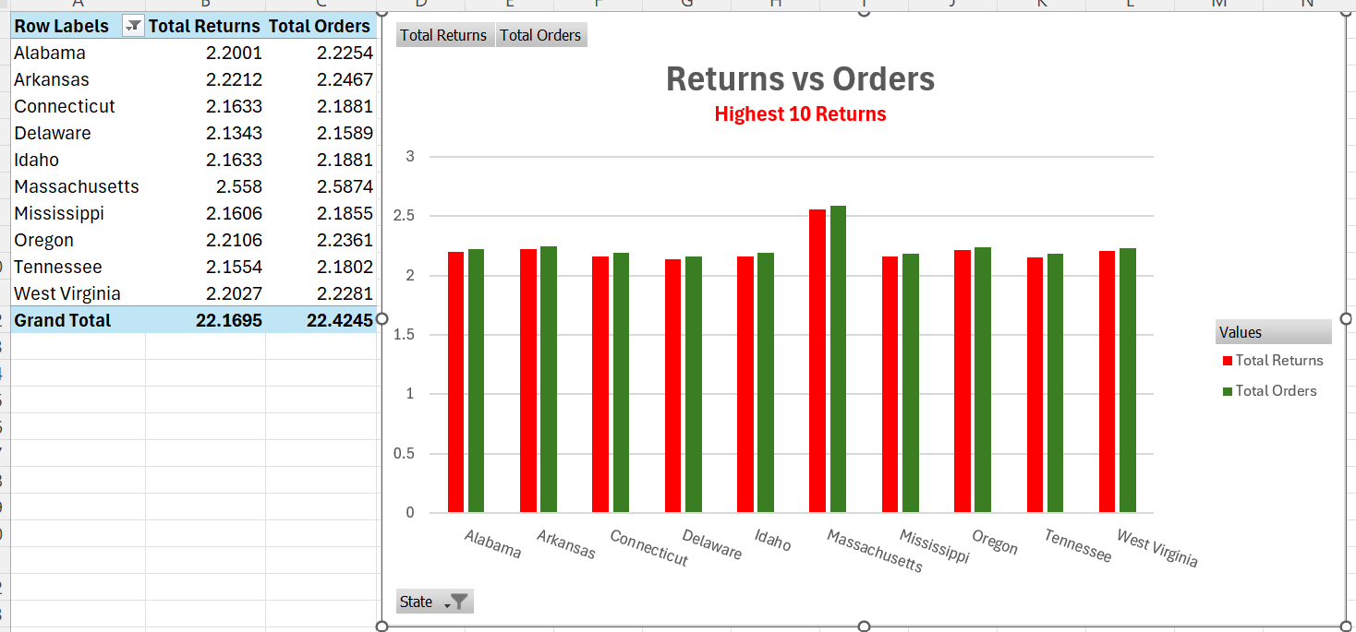

Top 10 States for Lowest percentage of Returns: The lowest percentage of returns are in South Carolina.
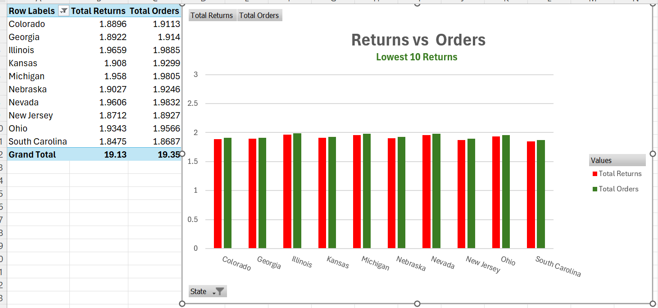
- Insight: It appears that the correlation between orders and returns by states is very similar. There are an extremely high number of returns, though I have limited the analysis to the top and bottom 10 as constraints.

The following shows: Overall orders and total returns by product.

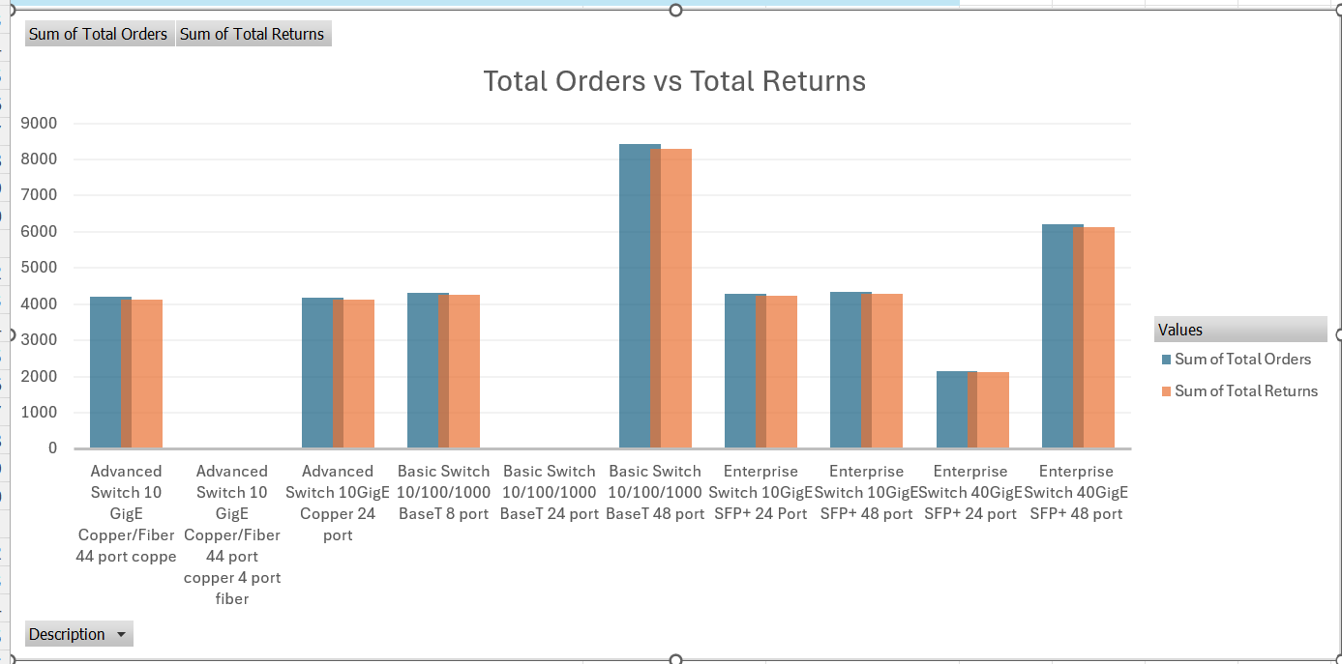

- Insight: We are consistently seeing that regardless of state, returns are almost as many as the original orders. We may want to look at this in another way by examining the products that are returned most and the reasons.

Insights and Recommendations

This shows us the reason for return by product. We can see there is an overwhelming amount of incorrect that exceed defective and ‘other’ reasons.
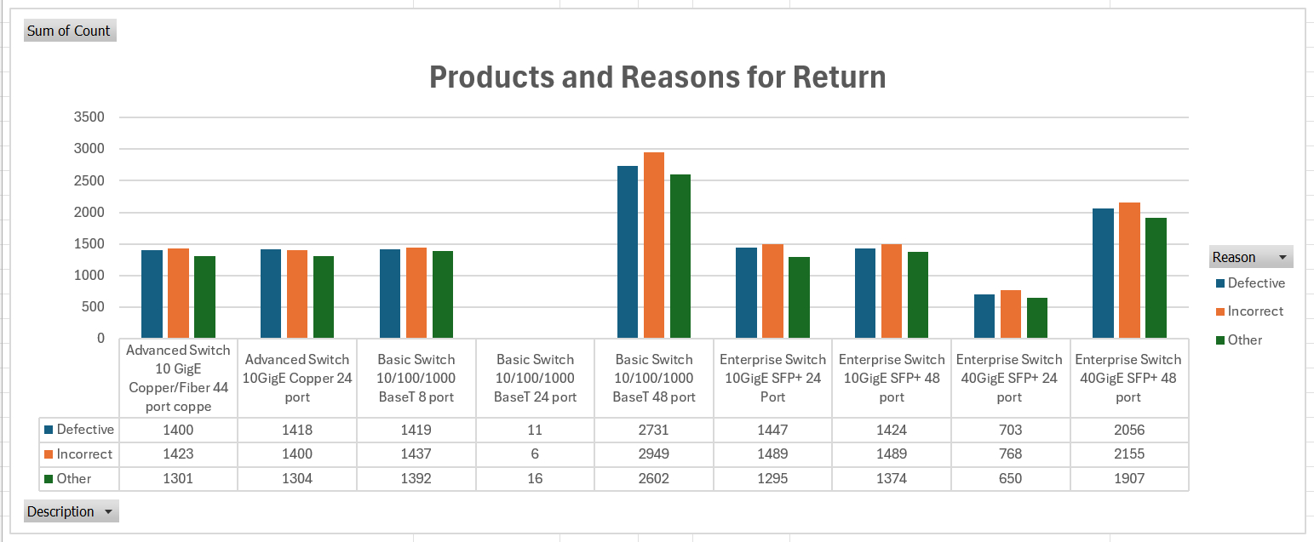
Although the Basic Switch 10/100/1000 BaseT 24 Port has few returns it is not a high seller either. However, the same model with 48 ports is the top seller.

- Insight: The packing and shipping department is inefficient. Further information would be needed from that department to drill down in more detail for root causes.

- Insight: This report is based on the data available in the Orders, Returns, and Customer data. Potential flaws include the unknown meaning of “Other” for return reasons.

